**Documentation of Payper LLC.**

1. **Signup:**

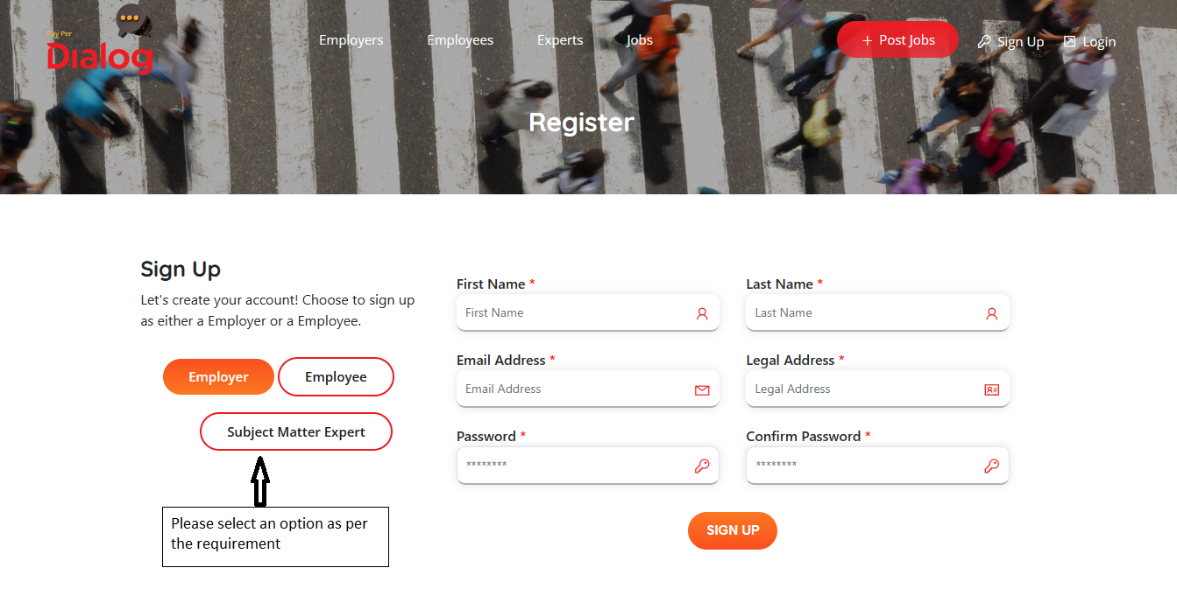

1. **After click on the signup button user will get an email to their email id.**

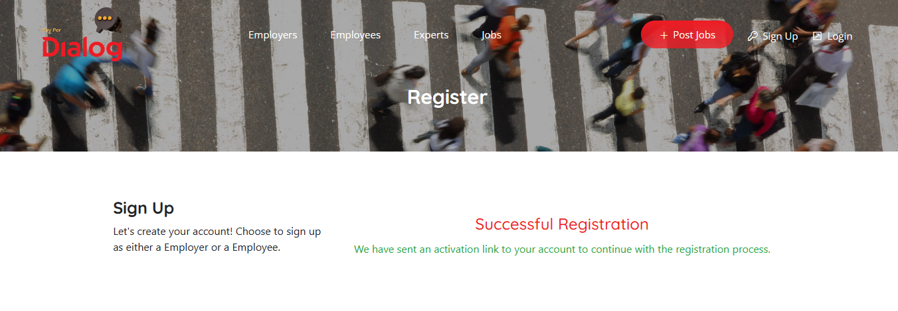

1. **Click on the “Activate” button.**

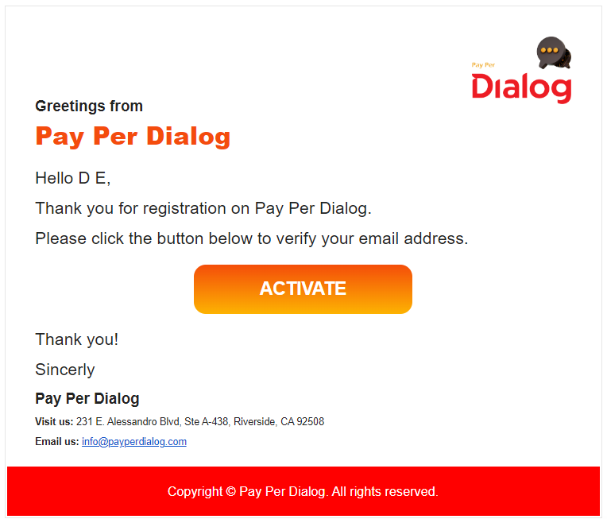

1. **Log in using the valid credential:**

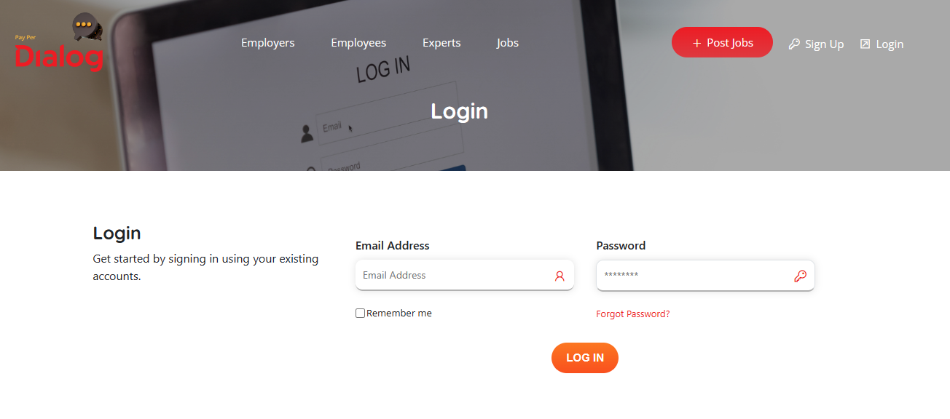

1. **After Login It will redirect to profile page. User will get a pop-up of “User’s Agreement” one time.**

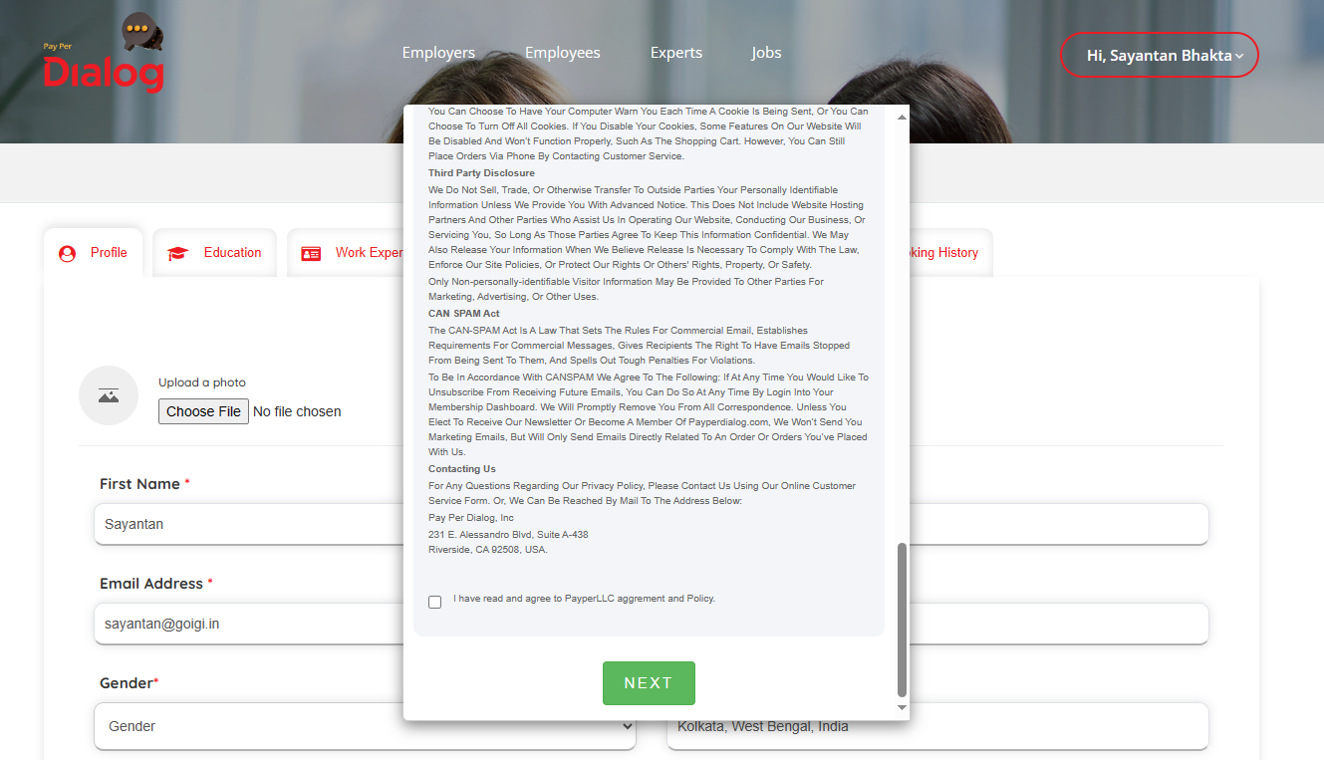

1. **User need to fill required filled to access the other tabs.**

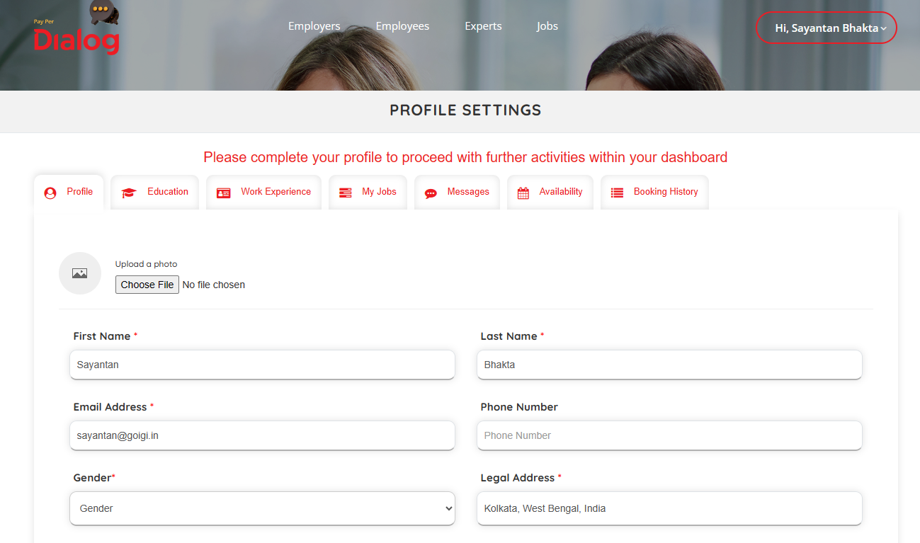

1. **Employee List Page:**

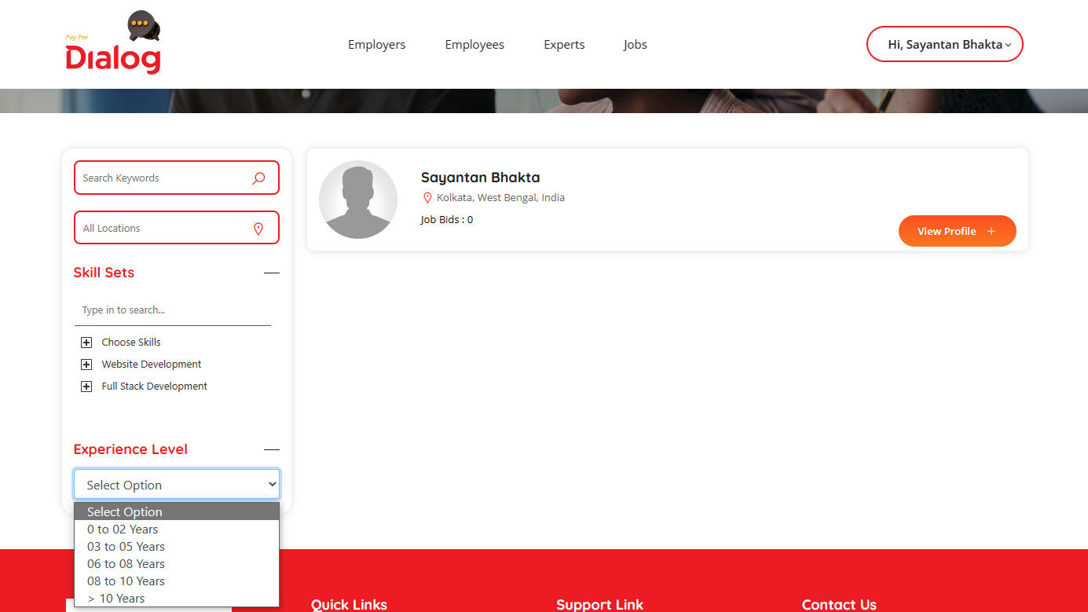

1. **Employer List Page:**

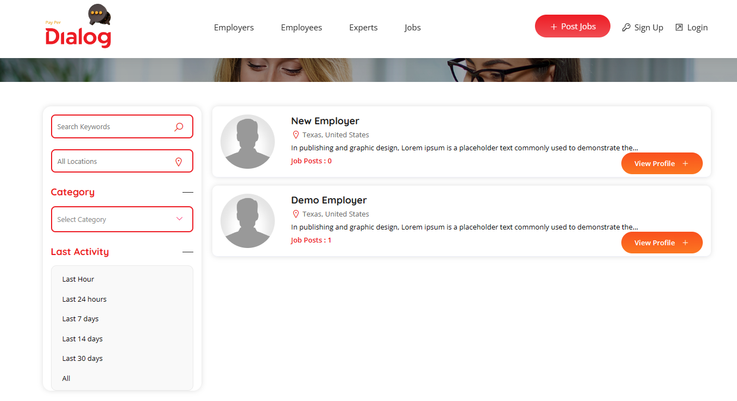

1. **SME List Page:**

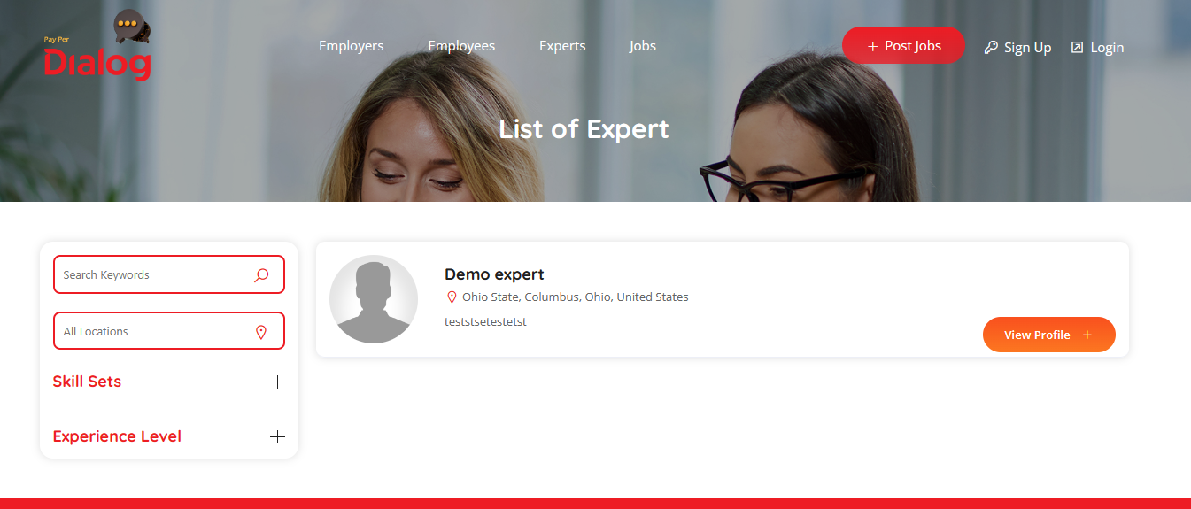

1. **Job List:**

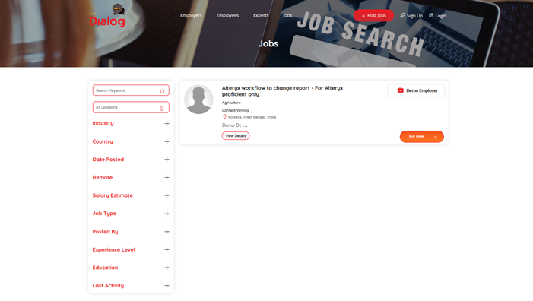

1. **Job Details Page:**

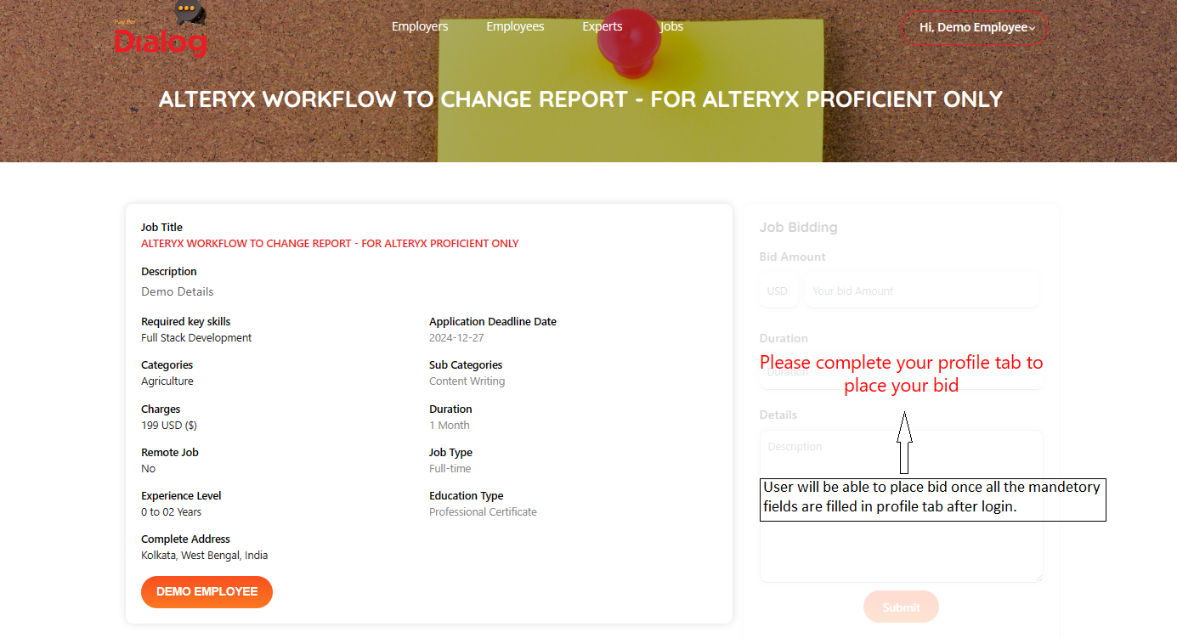

1. **After placing bid employee will get their list of bids on their profile “My Jobs” tab and employer will get their list of job post on “My Jobs” tab. From there employer can view, edit/update, and delete the job.**
2. **Employer will see List of Bids based on their posted job on “List of Bids” tab. From this list of bids tab employer can shortlist, accept and reject the related jobs. Short listed employee can communicate with employer through “Message” tab section. Once employer select a particular employee for a job, other employees bid will be rejected automatically for that particular job and message will delete for the rejected employee.**
3. **Recommended Employer:** In this tab employer can see all the recommended employee related to the job post and employer can search employee by choosing from the option.
4. **Booking History for employer:** Employer can see the booking history for employee by selecting date.
5. **Availability for Employee:** Employee can add availability with one-day time period. Once employee click on the calendar date it will show a popup with date and time field. Please find the below screenshot.

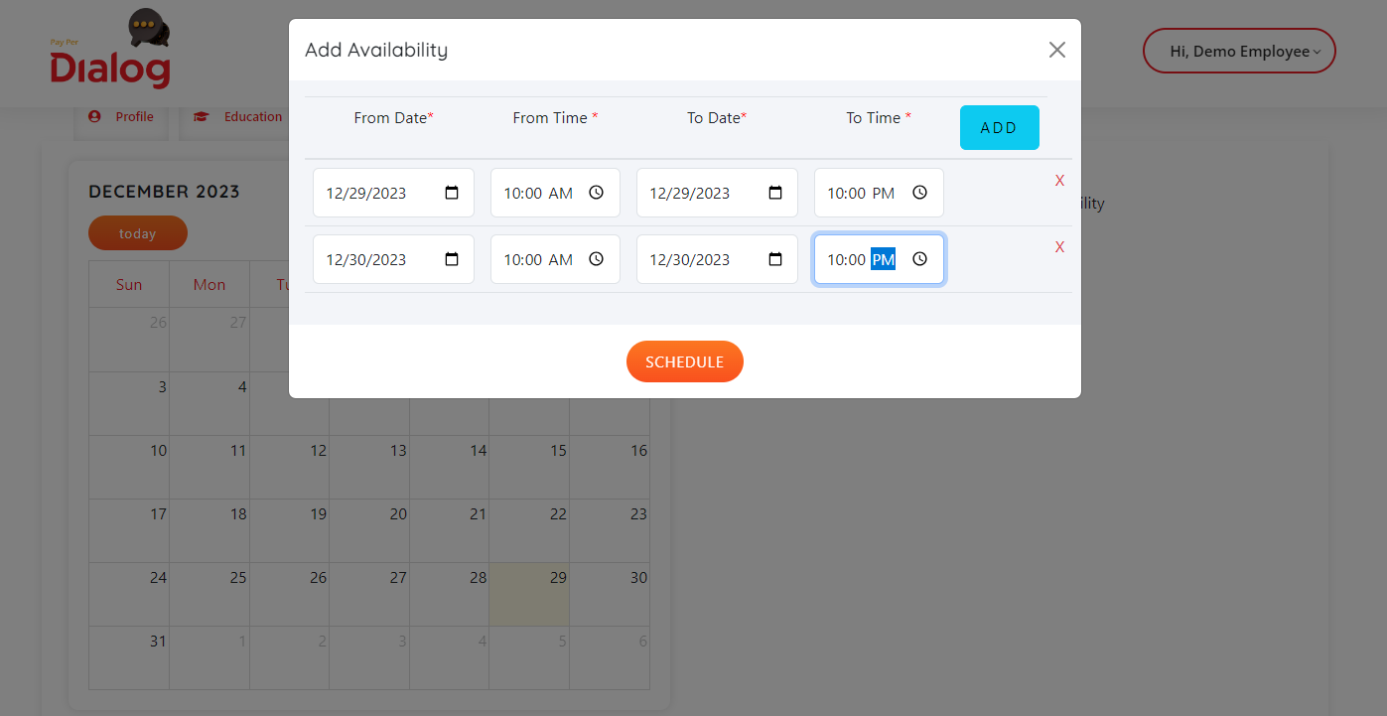

1. **Booking History for employee:** Employee can see the booking history, like (Employer name, rate, and booking slot).
2. **Employee Details Page:** Employer will be able to book slot from the employee details page. After selecting the slot employer need to accept the agreement, then only they can pay to the employee. Please find the below screenshot.

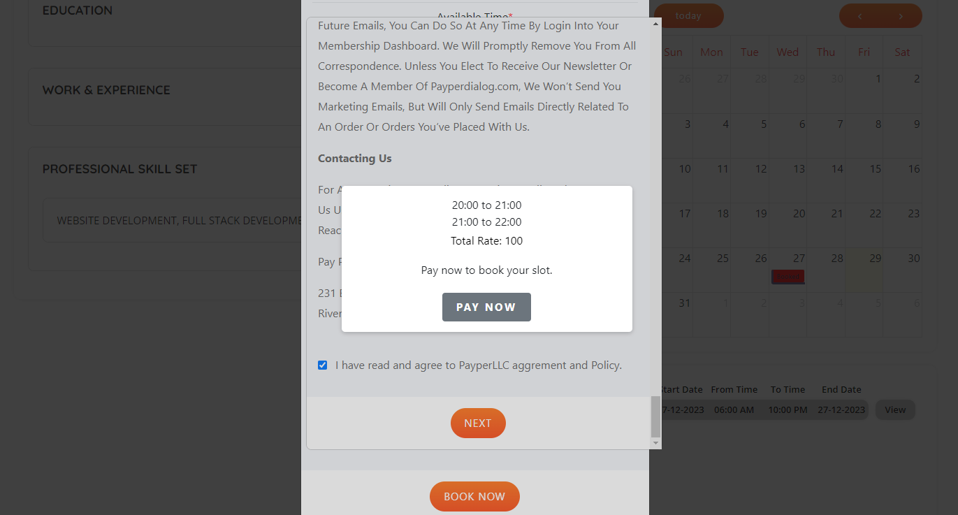

**Admin Portal Instruction**

1. **Industry/Category:**

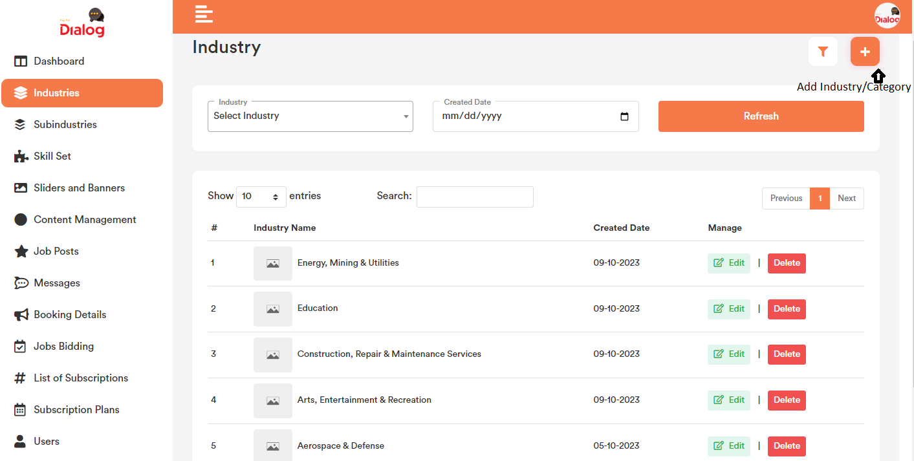

1. **Subindustry/Subcategory:**

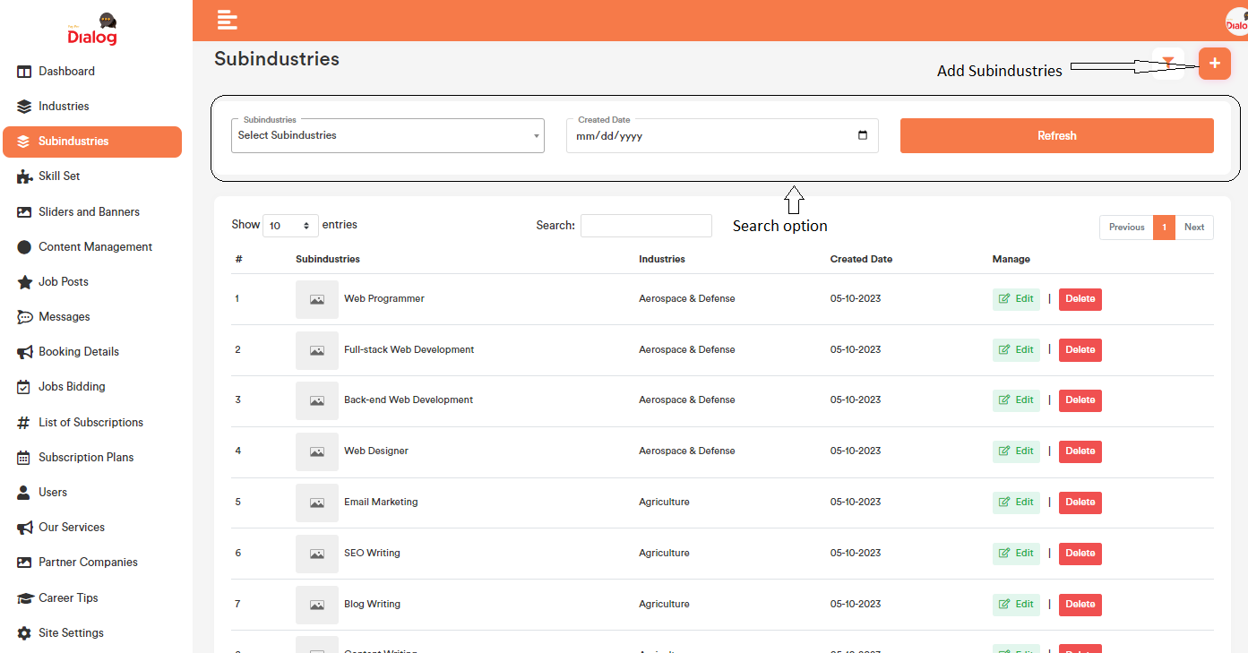

1. **Skill Sets:** For adding post job.

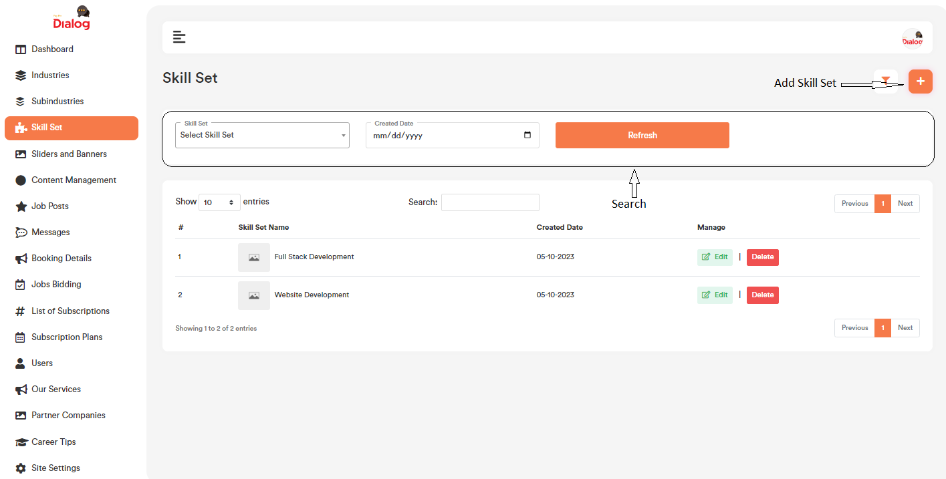

1. **Slider and Banner:** It will show in the frontend page banner.

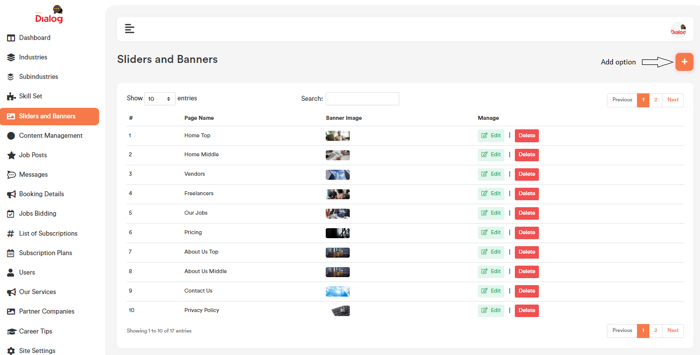

1. **Content Management:**

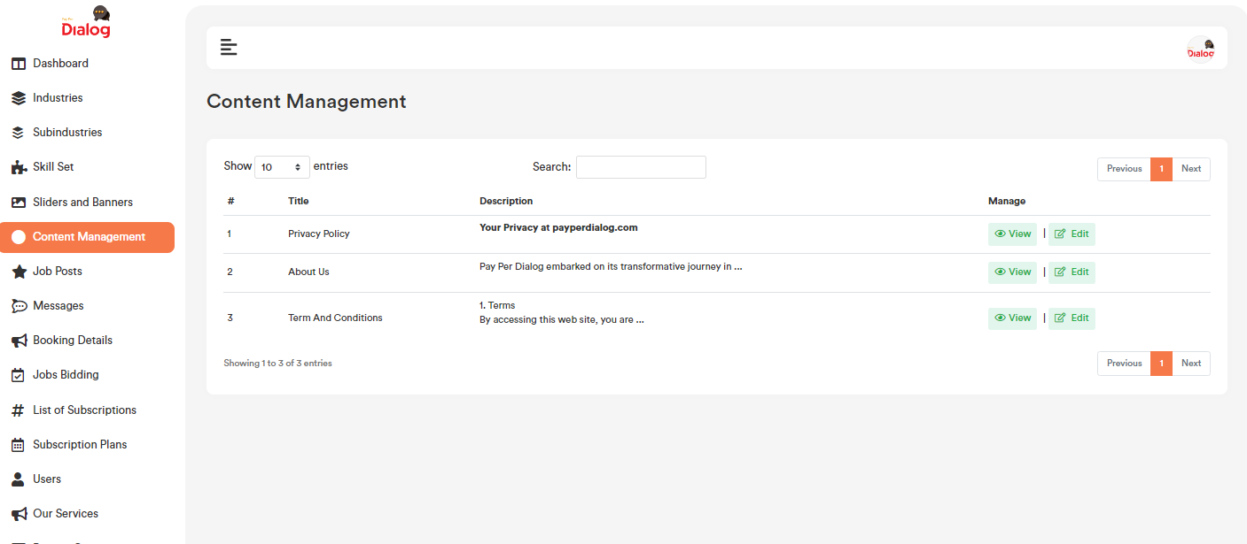

1. **Job post:**

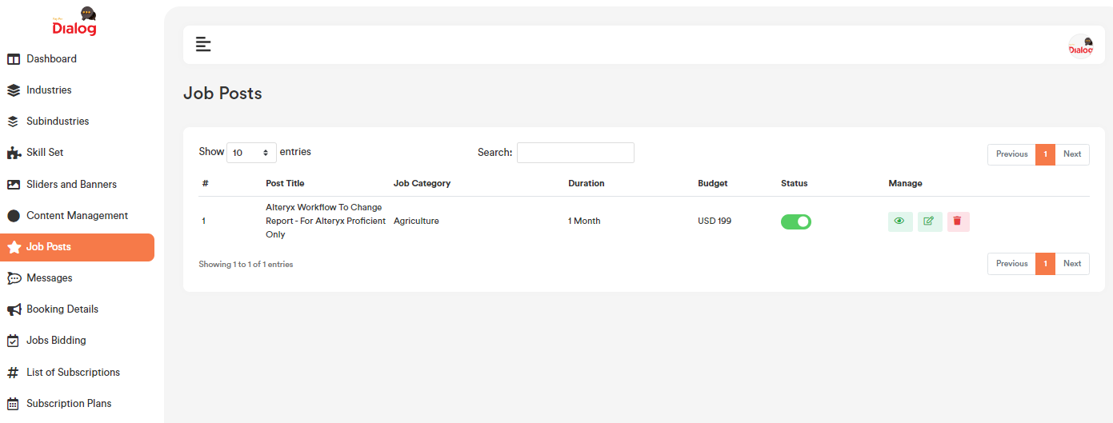

1. **Message:** Each conversion of employer and employee.
2. **Booking details:** Will show all the booking list with time slot and rate.
3. **Job Bidding:** Will show all the jobs bided by employee.
4. **Users subscription:** Will show the list of user’s subscription for the website.
5. **Subscription Plan:** Will show the subscription plan list.
6. **Users:** Will show the list of users (Active and inactive) in this section. Also Admin can active/inactive and delete any user.
7. **Our Services:** Admin can add, edit/update, and delete our service in the website. Which will show in the home page of the website. Please find the below screenshot.

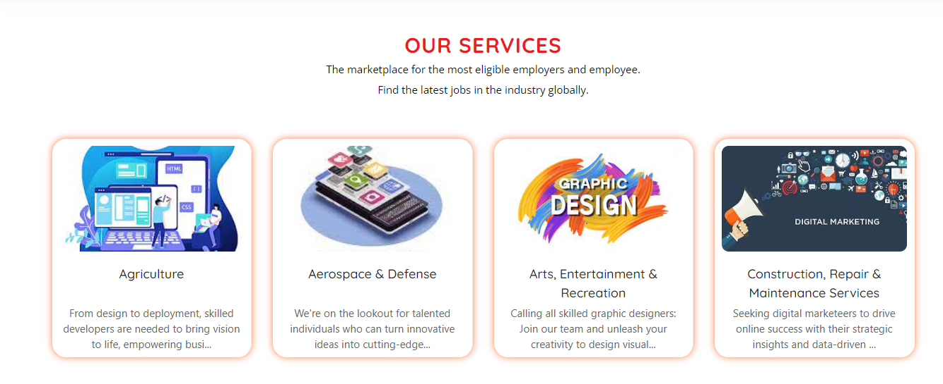

1. **Partner Companies:** Admin can add, edit/update, and delete partner companies in the website. Which will show in the home page of the website. Please find the below screenshot.



1. **Career Tips:** Admin can add, edit/update, and delete career tips in the website. Which will show in the home page of the website. Please find the below screenshot.

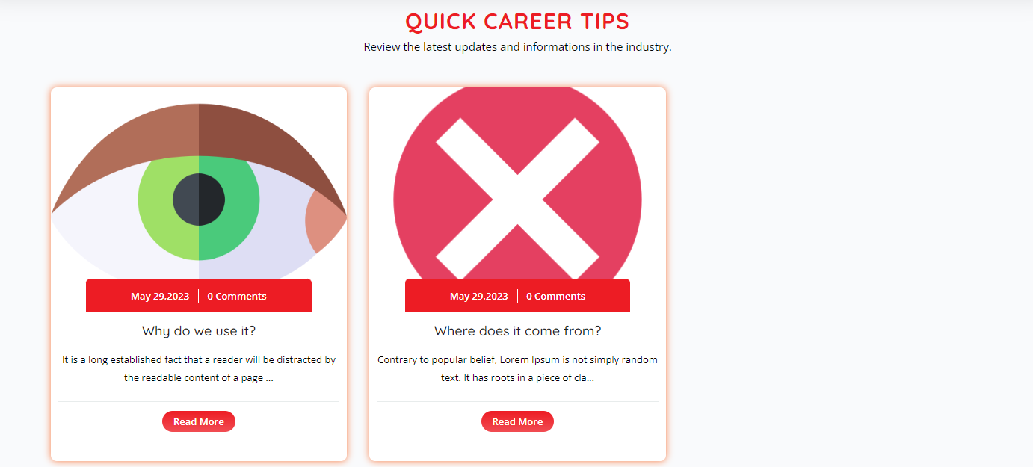

1. **Settings:** From where admin can change website name, address, about website, header logo, footer logo, favicon. Social link, admin commission, and also can enable and disable “required subscription” for the website.

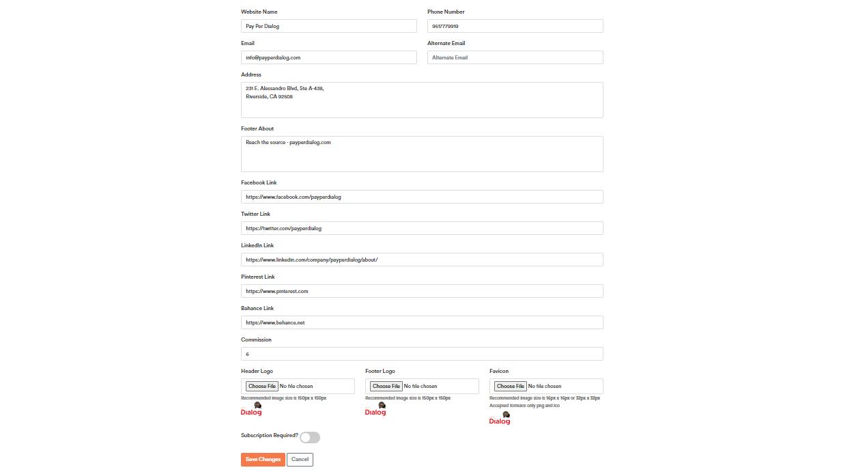

1. **Change password**: Admin can change password.

